29.63: a)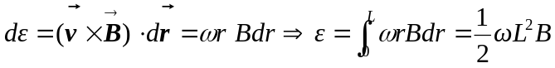
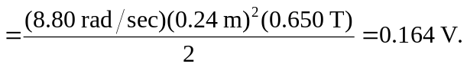
b) The potential difference between its ends is the same as the induced emf.
c) Zero, since the force acting on each end points toward the center.

